Application note 009, rev 1

Further guide to calculate programmed sums, demonstrated with the Euler-Mascheroni and the C47 Σ_{n} function. This is based a contribution made by C47 enthusiast Jozef Ongena, and written up by Jaco and illustrates the remarkable fast converging series for the Euler-Mascheroni constant:

This is a modification of the original Euler-Mascheroni formula by Brent:

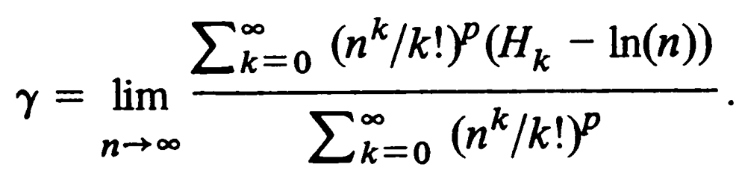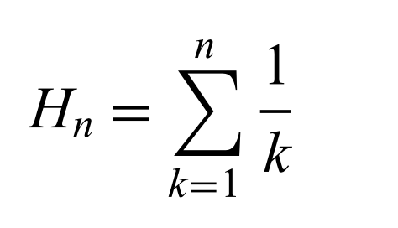
Euler-Mascheroni (Brent et al)(Eqn. 17) Harmonic number,

The exponent p and the fixed value for n can be chosen in function of the precision required, as explained in Brent's referenced paper. For n in the formula, we used 30, which should allow a precision of more than 30 digits, but the accuracy is tested for below in the C47 program.

Jozef: “The advantage of the series by Brent is that the original definition of the Euler-Mascheroni constant (lim n->inf (Hn - ln(n))) is very slowly converging. This (Brent) series is very fast. Only 100 terms have to be taken to get ~25 precise numbers! And it takes a minute or so connected to the power with the C47!”

Breaking down Brent’s formula into numerator & denominator, as well as the Harmonic Number generator and the main program which sequences the finite sums:
C47 Program file export: Export format version 2, C47 program version 1.
0000: { Prgm #46: 59 bytes / 21 steps }
0001: LBL 'denom'
0002: 30
0003: RCL T
0004: Y^X
0005: RCL T
0006: X!
0007: /
0008: 2
0009: Y^X
0010: STO 11
0011: 1
0012: RCL T
0013: 1
0014: SUMn 'HarmN'
0015: 30
0016: LN
0017: -
0018: RCL 11
0019: *
0020: RTN
0021: END
C47 Program file export: Export format version 2, C47 program version 1.
0000: { Prgm #45: 28 bytes / 11 steps }
0001: LBL 'numer'
0002: 30
0003: RCL T
0004: Y^X
0005: RCL T
0006: X!
0007: /
0008: 2
0009: Y^X
0010: RTN
0011: END
C47 Program file export: Export format version 2, C47 program version 1.
0000: { Prgm #47: 65 bytes / 15 steps }
0001: LBL 'EulerM'
0002: 1
0003: 100
0004: 1
0005: SUMn 'denom'
0006: STO 01
0007: 1
0008: 100
0009: 1
0010: SUMn 'numer'
0011: STO 02
0012: RCL 01
0013: /
0014: 1/X
0015: .END.

C47 Program file export: Export format version 2, C47 program version 1.
0000: { Prgm #44: 12 bytes / 4 steps }
0001: LBL 'HarmN'
0002: 1/X
0003: RTN
0004: END

Main program, numerator

Harmonic number calc Denominator
C47 results:

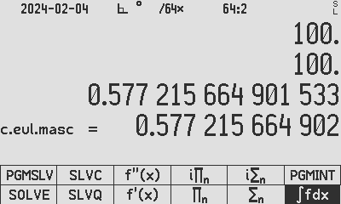
Y: Result of the above programmed series
X: Built-in constant 𝛾_{EM}

Subtracting the built-in Euler-Mascheroni constant from the series result, the resulting accuracy for p = 2 is shown to be 6.749849059 x 10⁻²⁵.

Raising the arbitrarily chosen p from 2 to 4 (line 8 of [denom] and [numer]) increases the accuracy to 1 x 10⁻³⁴, see the table below.

p | n | Number of terms | Proximity to the Euler Constant
2 | 30 | 100 | 6.749849059 x 10⁻²⁵
4 | 30 | 100 | -1 x 10⁻³⁴

Source for the example: MATHEMATICS OF COMPUTATION, VOLUME 34, NUMBER 149, JANUARY 1980, PAGES 305-312, Some New Algorithms for High-Precision Computation of Euler's Constant, link

Author Jaco Mostert & Jozef Ongena

Copyright (C) 2024 The C47 Development Team. Permission is granted to copy, distribute and/or modify this document under the terms of the GNU Free Documentation License, Version 1.3 or any later version published by the Free Software Foundation; with no Invariant Sections, no Front-Cover Texts, and no Back-Cover Texts. A copy of the license can be downloaded from gnu.org.

